AVIS/008/2020-21 Date: 16th May 2020

Dear Parents,

In earlier years of school, you were probably given a list of supplies to buy for the new academic year. When we start school, however, this decision is mostly up to you. Depending on your individual needs, we suggest the following definitive online school supply list so you’re prepared to start the term right in the month of June.

School recommends the following prerequisites

- Reliable computer/laptop with a good camera, headphones & mic - You’ll need a reliable computer with a HD screen(720p) that operates at a good speed and is able to handle a variety of different programs. This doesn’t mean you have to splurge on the latest and most expensive model, but you should be able to work with minimal issues.

- Good internet bandwidth: School uses HD cameras to broadcast online classes. We recommend a wired broadband connection with at least 30 MBPS speed (5.0 Megabits per second - Recommended for HD quality if only one device is connected & used at a time). Your internet should also be reasonably fast and reliable, and it’s not a bad idea to come up with a few backup options (like dongle, hotspot) for getting online if your primary connection is having issues.,

- Ergonomic study space - Unlike in a traditional classroom setting where students tend to move from one
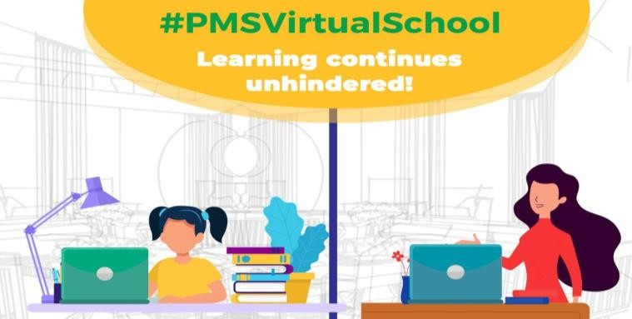
classroom to another, you may find your child sitting in one spot for a while as they engage in online learning. With this in mind, you should have a comfortable chair that you can adjust to the right level to see your computer easily. Carve out a separate school area with a desk for their files, textbooks and other items. This will help them focus and get down to work more easily than if they were working on a couch or bed.

In case there is no access to a computer/laptop and if you have been using a mobile phone or tab to access online classes we suggest you to use below devices for your child’s comfort.

- Chromecast: Chromecast is a small media streaming device that plugs into the HDMI port on your existing TV. Use your iPhone®, iPad®, Android phone and tablet, Mac® and Windows® laptop, or Chromebook to cast/mirror zoom app (online classes) to the big screen to reduce eye strain. More info @ https://chromecastappstips.com/how-to-chromecast-zoom-to-tv/

Tabs:
Apple iOS Tablet: iPad Mini, iPad or iPad Pro - iOS 8.0 and higher recommended Android Tablet (e.g. Samsung Galaxy Tab S4) - Android OS: Android 4.0 and above Screen size: 8.0 inch and higher: CPU: ARM v6+ or x86; dual core 1.5 GHz and above

- Parental Controls: When you turn on parental controls, you can restrict what content can be accessed or downloaded from the internet based on maturity level. There are many free apps for desktop version as well as on app store/play store for mobile/tab which can be downloaded and enabled. Eg: Qustodio, Kaspersky Safe Kids, Norton Family Parental Control, Net Nanny etc.,

Have more questions? Feel free to do a little research through the internet or your service provider before finalizing. We will be sending another circular on netiquette guidelines for your wards online classes shortly.

Regards

Vanaja

Principal

